

Early Learners Academy

Curriculum Concepts
September 2025 - August 2026

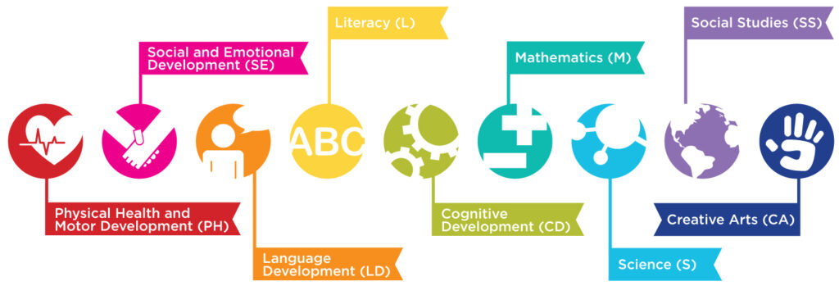


Weekly Themes
9/1-9/5: All About Me/ Family
9/8-9/12: Classroom Routines / Rules
9/15-9/19: Building Friendships / Teamwork / Kindness
9/22-9/26: Pets
September
Back to School
ask the experts >>>
.


Monthly Concepts

Letters: A, M, P
Numbers: 1, 2
Color: Yellow
Shape: Circle
Country: Italy
Culinary: Green, red and yellow apples with yogurt dip
Art Medium: Apples cut in ½ , red, yellow, green stamp pads
Sight Words: a, and

Spanish and Sign Language:
School – Escuela

Family – Familia

LEARNING STANDARDS Spotlight:
Language Development
Component 1: Receptive/Interpretive Language
Standard 1.a: Children attend to, understand, and respond to increasingly complex language.

Important Dates / Events
9/1: Labor Day ELA closed
9/2: First Day of School (Preschool Transitions)
9/5: Grandparents Tea Event 3PM
9/12: Wear Yellow to school

*Educational Program- Music and Author Greg Lato TBD

Author of the Month
Anna Dewdney

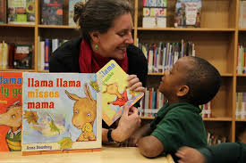
Books Written by Anna Dewdney
Llama, Llama Red Pajama
Llama, Llama Mad at Mama
Llama, Llama Misses Mama
Llama, Llama Time to Share
Llama, Llama Goes To School
Family Participation
Apple Tree Name Recognition Daily Activity

Welcome! Please take a minute at drop off during the month of September, to assist your child to sign in just like you do by placing their apple with their name on it on the apple tree. This is a great way to encourage your child to recognize their name and create a routine for drop off to help your child settle in.
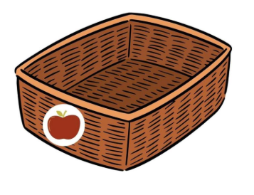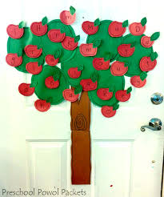


Weekly Themes
9/29-10/3: Apples on Top
10/6-10/10: Fire Safety and Community Helpers
10/13-10/17: Farmers Market
10/20-10/24: Fall Changes (Leaves, Trees) /Pumpkins
10/27- 10/31: Halloween

October
Fabulous Fall


Monthly Concepts

Letters: S, T
Numbers: 3,4
Color: Orange
Shape: Square
Country: Egypt
Culinary: Spiders on a log (Fruit or celery sticks, yogurt, cream cheese or sun butter, with raisins
Art Medium: Watercolor paints, white contruction paper, stencils
Sight Words: it, be

Spanish and Sign Language:
Pumpkin - calabaza

Trees - árbol


LEARNING STANDARDS Spotlight:
Mathematics
Component 1: Number Sense and Quantity
Standard 1.a: Children develop number recognition and counting skills and learn the relationship between numbers and the quantity they represent.

Family Participation
Pumpkin Decorating Contest
Please bring in a decorated pumpkin before the Halloween Spooky Trail Event to be displayed in the hallway for a contest. Votes will be casted during the Halloween Bash. Get Creative!

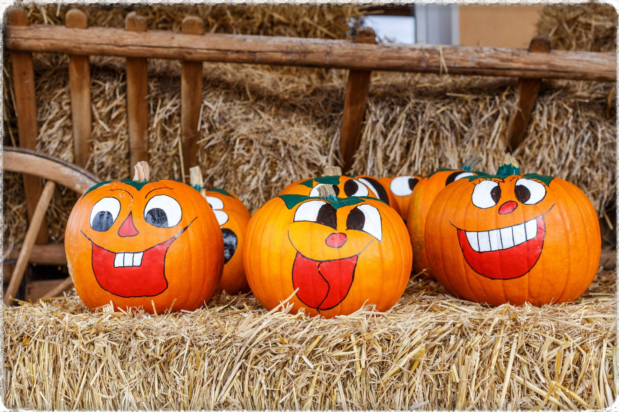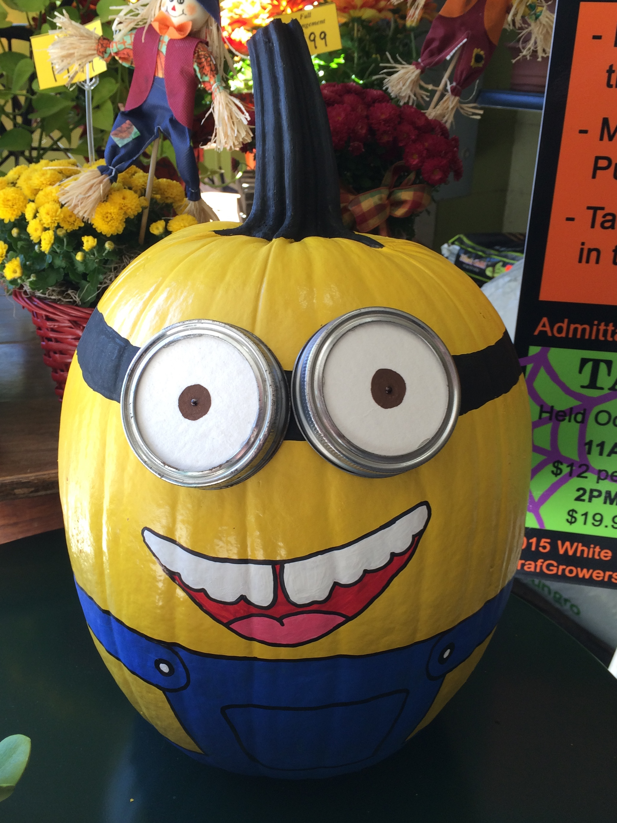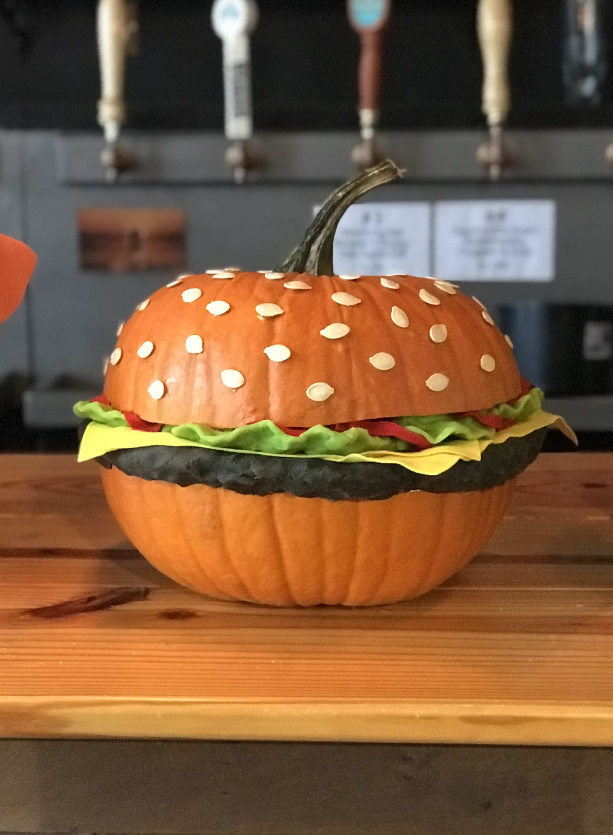
Important Dates / Events
10/10: Wear Orange to School
10/13: Indigenous Peoples Day ELA Closed
10/13-10/16: Families bring in their decorated pumpkins
10/17: Halloween Spooky Trail
10/31: Halloween Pajama Day, ELA closes at 4:00pm

*Firefighter visit TBD
*Fundraiser TBD

Author of the Month
Lois Ehlert


Books Written by Lois Ehlert
Growing Vegetable Soup
Eating the Alphabet
Red Leaf, Yellow Leaf
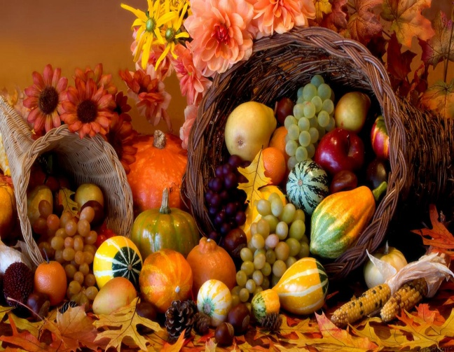

Weekly Themes
11/3-11/7: Nocturnal Animals
11/10-11/14-: Veterans Day / Giving Thanks
11/17 – 11/21: Thanksgiving (Turkey, Settelers)
11/24 – 11/28: Harvest Crops (Corn, Cornucopia)

November
A Thankful Heart

Author of the Month
Bill Martin Jr.


Books Written by Bill Martin Jr.
Brown Bear, Brown Bear What Do You See
Polar Bear Polar Bear, What Do You See
Chicka Chicka Boom Boom
Chicka Chicka 1,2,3

Important Dates / Events
11/3: Adopt a Soilder Collection Begins
11/3-11/4: Fall Picture Days
11/11: Veterans Day ELA Closed
11/14: Adopt a soldier items due
11/14: Wear Brown to school
11/26: Thanksgiving Friends Lunch ELA closes at 4:00 PM
11/27-11/28: Thanksgiving break ELA Closed

Family Participation
Disguise a Turkey

Take a Turkey Template from the front hallway. Disguese the turkey so its unrecognizable. Get Creative. Return your finished work to Miss. Andrea to be displayed in the hallway.
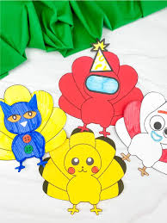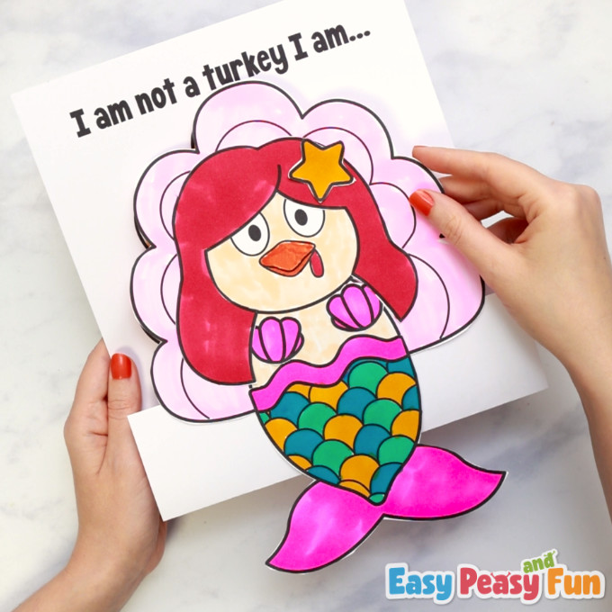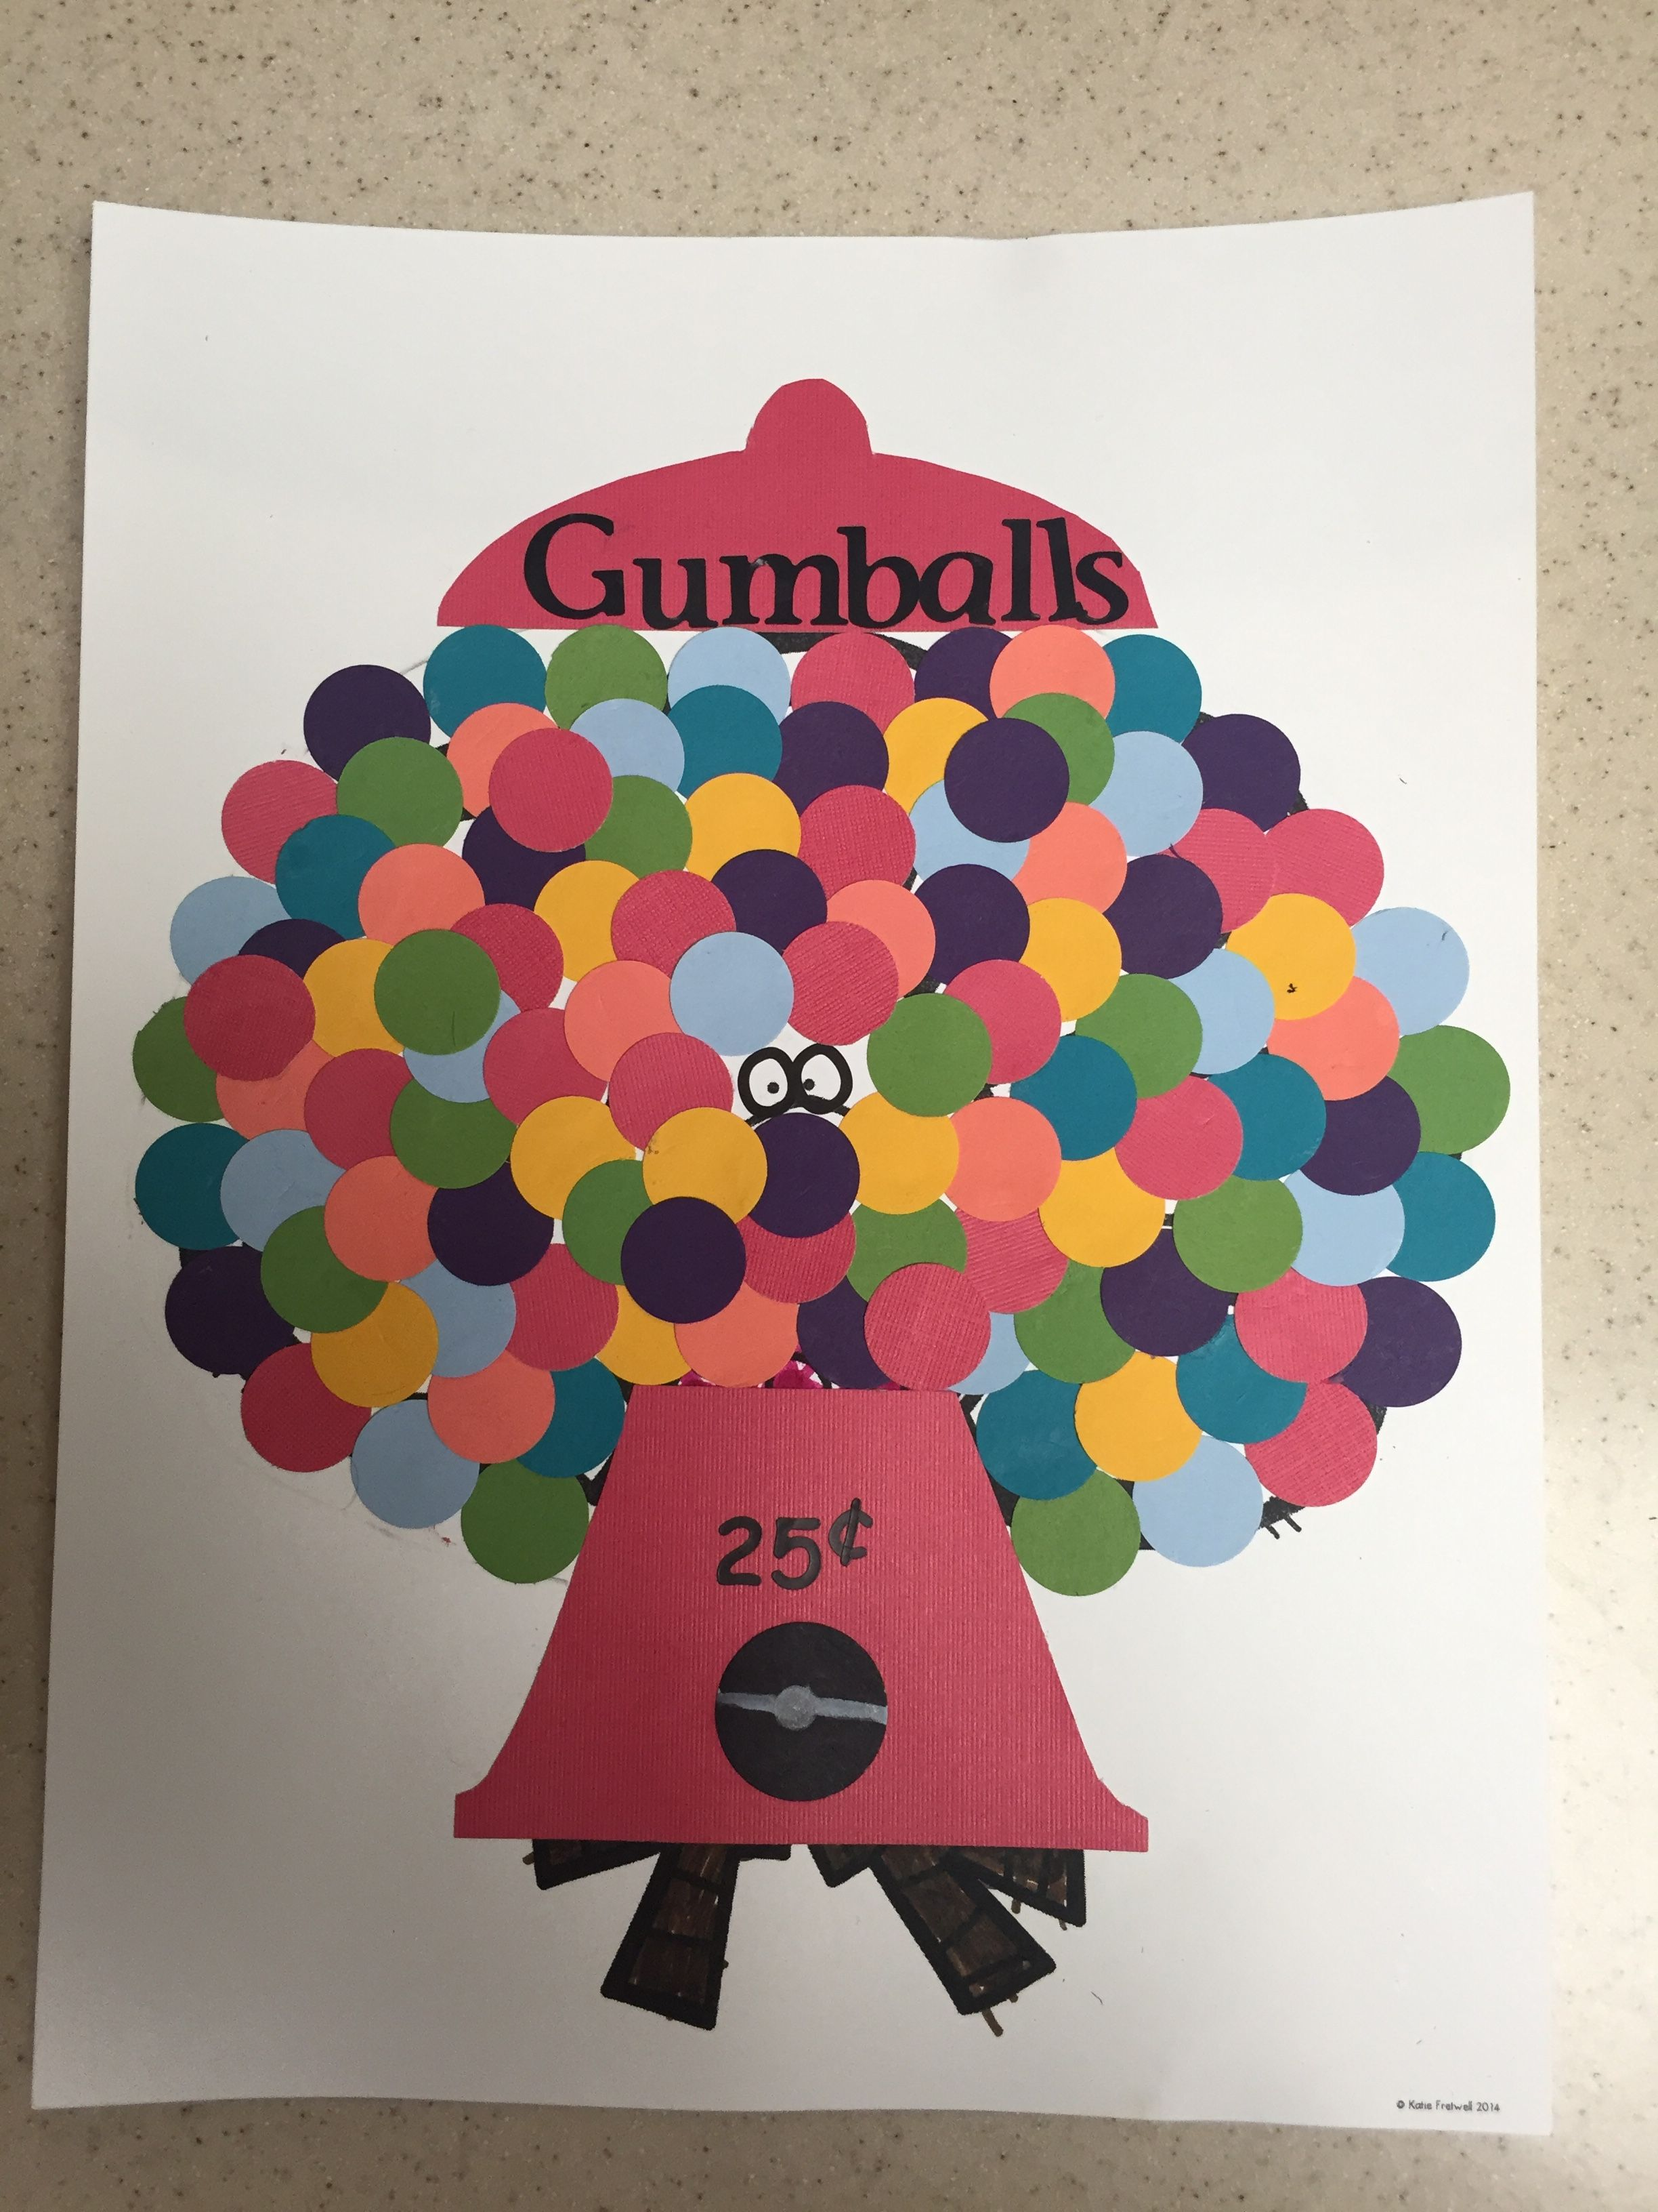
Monthly Concepts

Letters: B, H, G
Numbers: 5, 6
Color: Brown
Shape: Triangle
Country: Australia
Culinary: Pumpkin pie in a cup
Art Medium: Pincones, acorns, glue, Paper plates
Sight Words: come, for

Spanish and Sign Language:
Thank You - Gracias

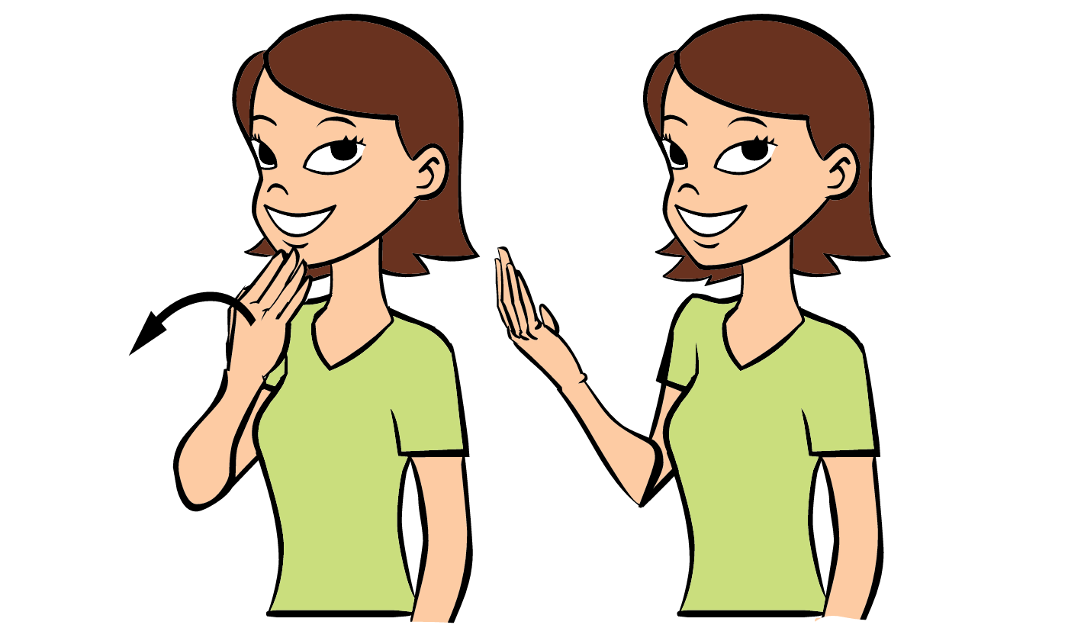
Turkey - Pavo

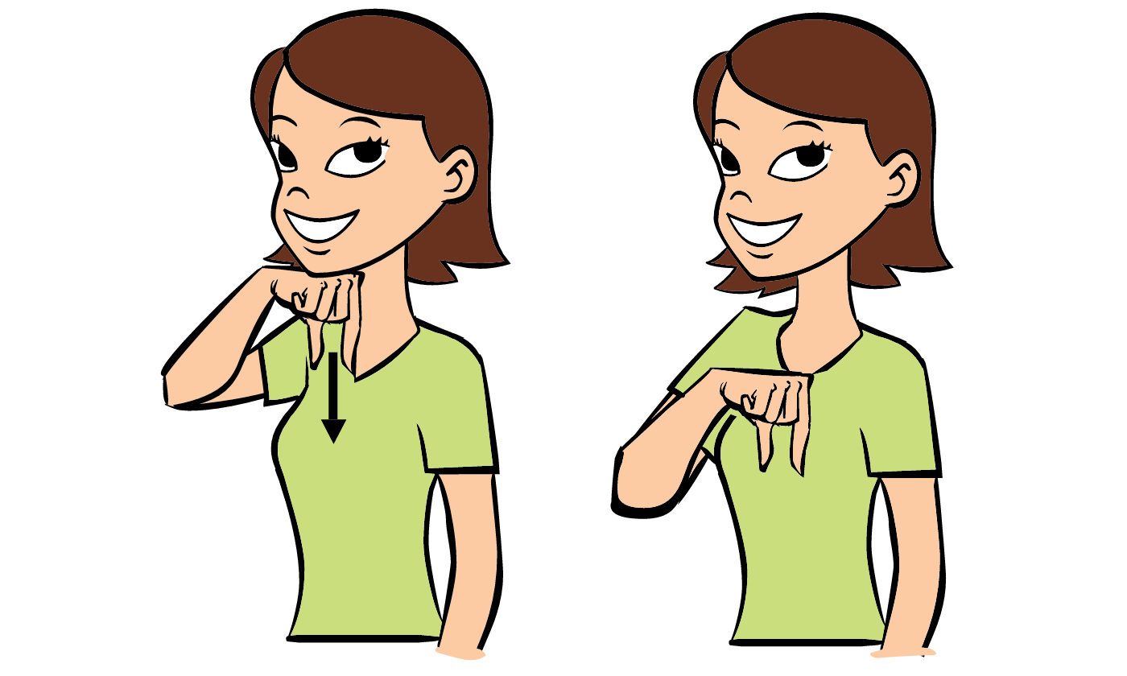

LEARNING STANDARDS Spotlight:
Social Studies
Component 4: Geography
Standard 4.a: Children demonstrate knowledge of geographical concepts of location and physical characteristics of the environments in which they live.


Weekly Themes
12/1-12/5: Christmas Treats (Candy canes, Gingerbread Houses)
12/8-12/12: Santas Helpers ( reindeers, elves)
12/15-12/19: Holiday Traditions Around the World
12/22-12/26: Christmas (Trees, ornaments, gifts)
12/29 – 1/2: *Christmas Break*

December
Holiday Traditions

Monthly Concepts

Letters: D, N, R
Numbers: 7, 8
Color: Red
Shape: Triangle
Country: Jamaica
Culinary: Ice cream cone Christmas Trees
Art Medium: Bows, Ribbons, green/red paint, paper.
Sight Words: can, down

Spanish and Sign Language:
Christmas - Navidad


Gift - regalo

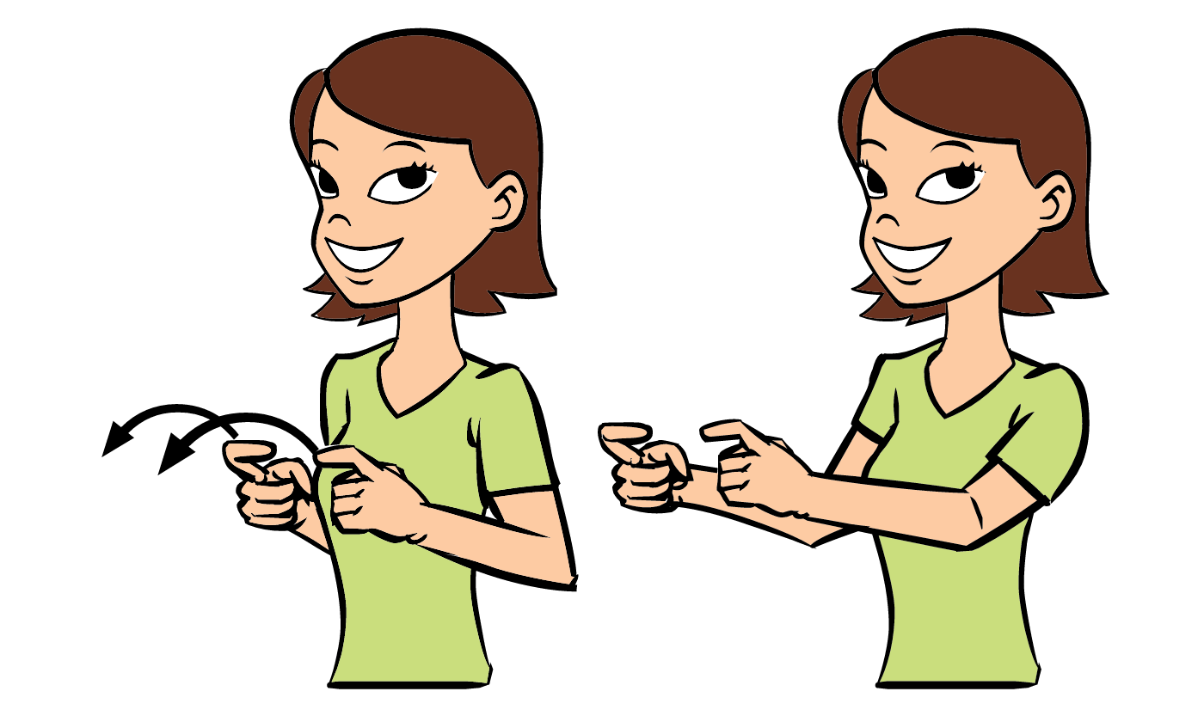
LEARNING STANDARDS Spotlight:
Social and Emotional Development
Component 1: Relationships with Others
Standard 1.b: Children engage in positive relationships and interactions with other children.

Family Participation
Gingerbread House Competition

As a family, decorate you own gingerbread house. You can chose to get a kit or make one from scratch with other items. Get as creative as you’d like. All gingerbread houses should be brought to school by December 12th. Voting will begin on December 15th and a winner will be announced on Friday December 19th. Good Luck!
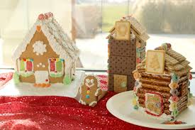
Important Dates / Events
12/8 - 12/23: Twelve Days of Christmas Spirit (theme days TBD)
12/12: Wear Red to School
12/15: All Gingerbreads Displayed; Voting begins.
12/19: Last day to vote for gingerbread houses
12/24: Christmas Eve ELA Closes at 12 PM
12/25-1/1: Christmas Break

*Santa Visit TBD
Author of the Month
David Shannon


Books Written By David Shannon
No, David!
David Goes to School
That’s Not Funny David!
A Bad Case of Stripes
David Gets in Trouble

Weekly Themes
1/5-1/9: Snowmen, snowflakes, ice
1/12-1/16: Winter Weather Attire
1/19-1/23: Arctic Animals / Hibernation
1/26-1/30: Winter Sports

January
Winter Wonderland



87
Monthly Concepts

Letters: C, L
Numbers: 9, 10
Color: White
Shape: Diamond
Country: Norway
Culinary: Polar Bear Yogurt Bowls
Art Medium: Painting on Snow
Sight Words: find, away

Spanish and Sign Language:
Ice - hielo
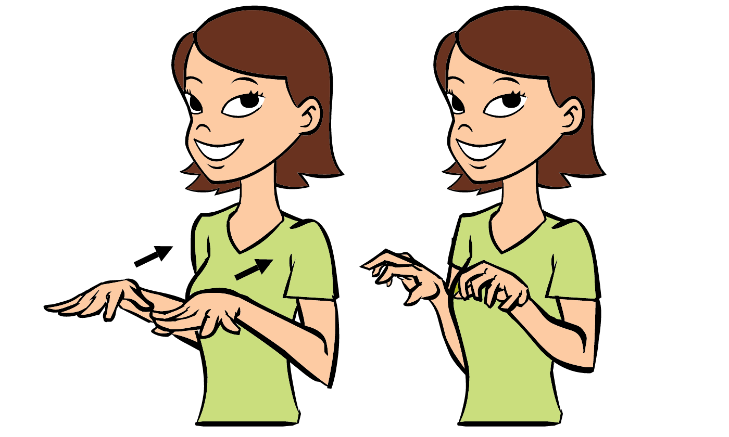
Cold – frio

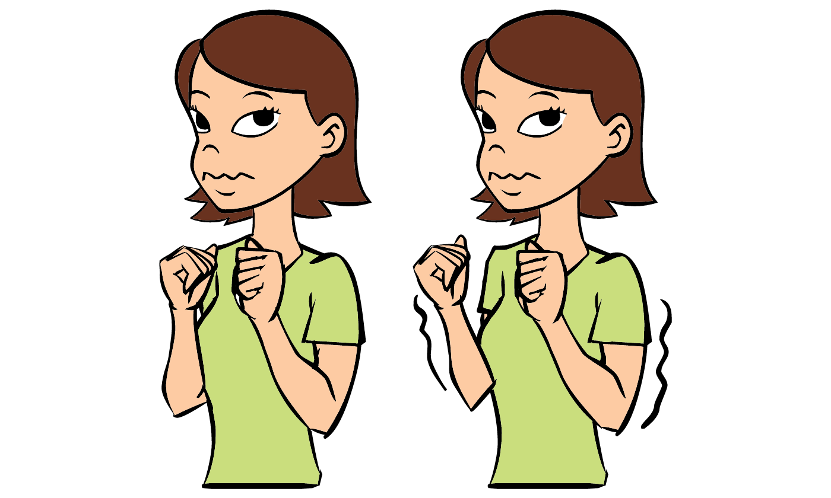

LEARNING STANDARDS Spotlight:
Literacy
Component 1: Phonological Awareness
Standard 1.a: Children demonstrate awareness of spoken words, syllables, and sounds (phonemes).

Important Dates / Events
1/1-1/2 Closed
1/9: Wear White to School
1/19: MLK Jr day ELA closed

*Owl Visit TBD
Family Participation
Snowglobe Craft

Take a snowglobe template from the front hallway. Decorate your snowglobe any way youd like. You can use paint, glitter, pom poms, pipe clearners, markers, anything. Return it to Miss. Andrea in the front office so it can be displayed in the hallway.

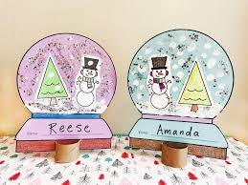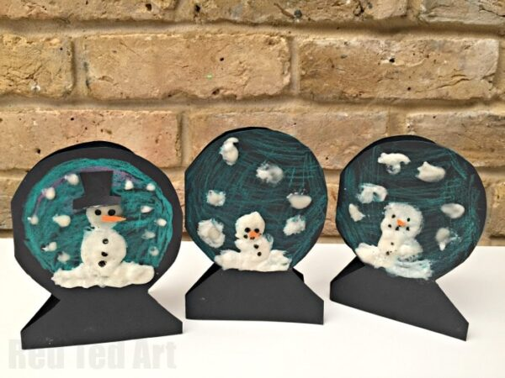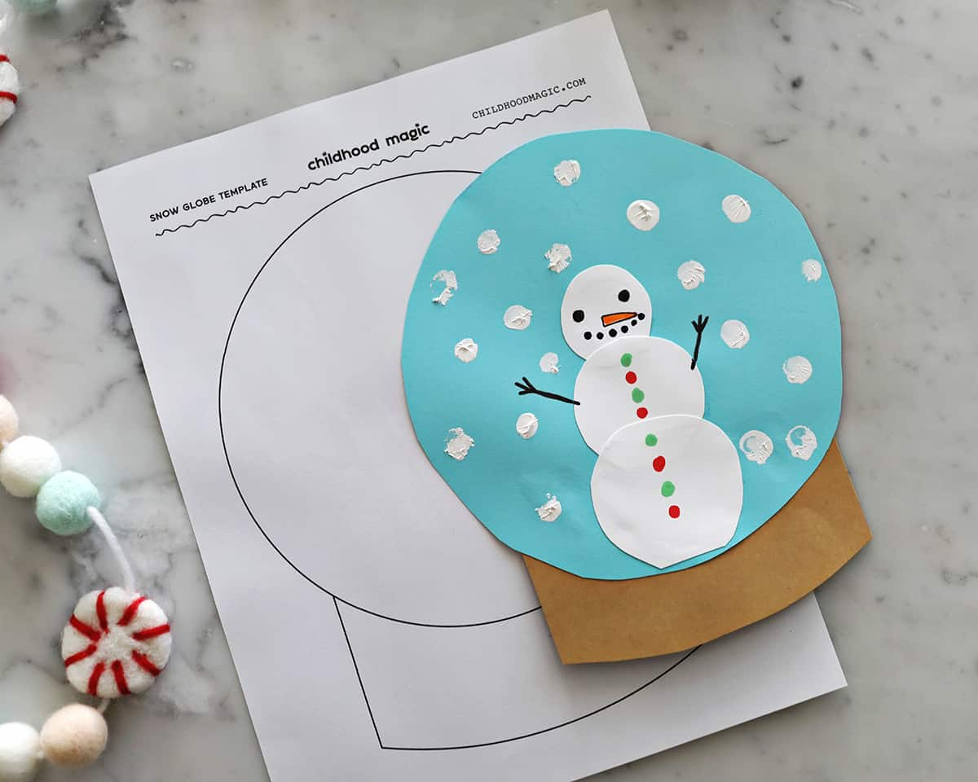
Author of the Month
Jan Brett


Books Written by Jan Brett
The Three Snow Bears
Gingerbread Baby
The Mitten
The Hat
Cozy

Weekly Themes


2/2-2/6: Five Senses
2/9-2/13: Valentines and Loved Ones
2/16-2/20: Dental Health
2/23-2/27: The Human Body

February
My Body and Senses


Monthly Concepts

Letters: F, J, O
Numbers: 11, 12
Color: Heart
Shape: Pink
Country: India
Culinary: Rainbow Fruit Kabobs
Art Medium: Pink/Red Tissue paper, Heart stencils, paper, colored pencils
Sight Words: look, go

Spanish and Sign Language:

Love – amar
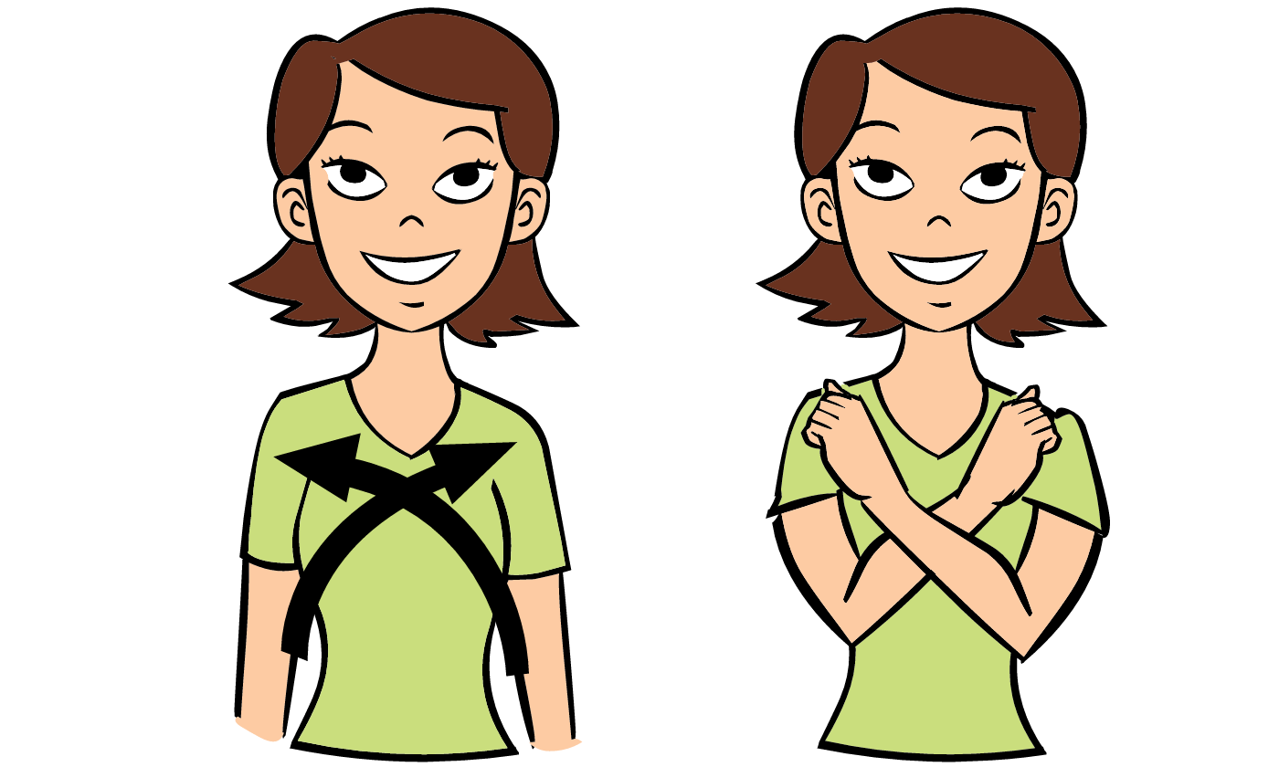
Heart - corazón

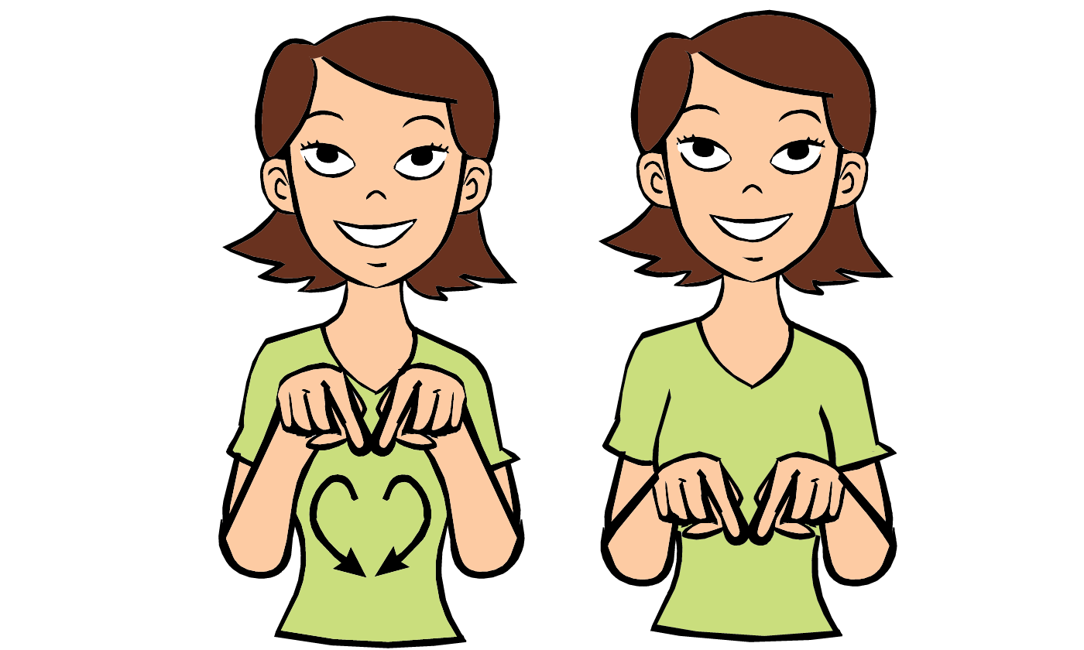

LEARNING STANDARDS Spotlight:
Physical Health and Motor Development
Component 1: Health and Safety Practices
Standard 1.c: Children develop self-help skills. Such as self feeding, hand washing, managing zippers, etc.

Authors of the Month
Grace Byers

Books Written by Grace Byers
I am Enough
I Believe I Can

Anne Wynter

Books Written by Anne Wynter
The Hands on book
Just Like You
No More Sleeping In
Family Participation
Love letters to your child

Love is in the air! Spread some love and write a love letter to your child. Place your letter in the mailbox in the front hallway. Every Friday, Miss. Andrea will deliver love letters to the classroom to be read to your child.
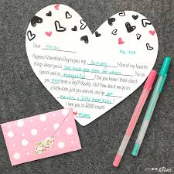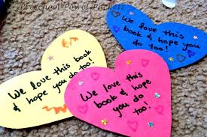
Important Dates / Events
2/3: 100th Day of School
2/13: Wear Pink to School
2/13: Snack with a loved one 2:45 PM
2/16: Presidents Day ELA Closed

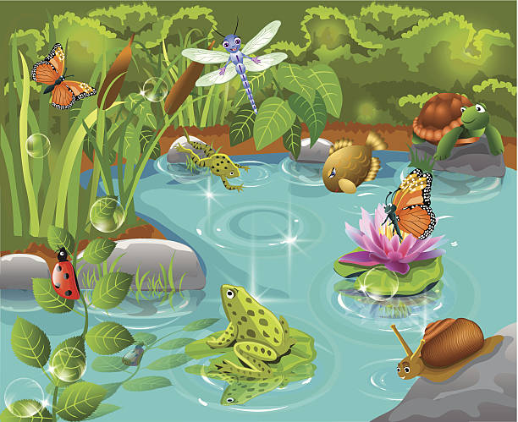
Weekly Themes
3/2 – 3/6: Dr. Seuss Week
3/9-3/13: Pond Life
3/16-3/20: St. Patricks Day / Lepruchauns / Rainbows
3/23-3/27: Birds, Bees, and Butterflies

March
March Madness

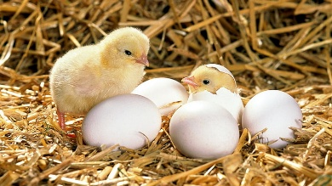
Monthly Concepts

Letters: I, X
Numbers: 13, 14
Color: Green
Shape: Rectangle
Country: Ireland
Culinary: Green Eggs and Ham
Art Medium: Shamrock cut outs, gold foils, glue, paper plates
Sight Words: here, help

Spanish and Sign Language:
Bird-pájaro

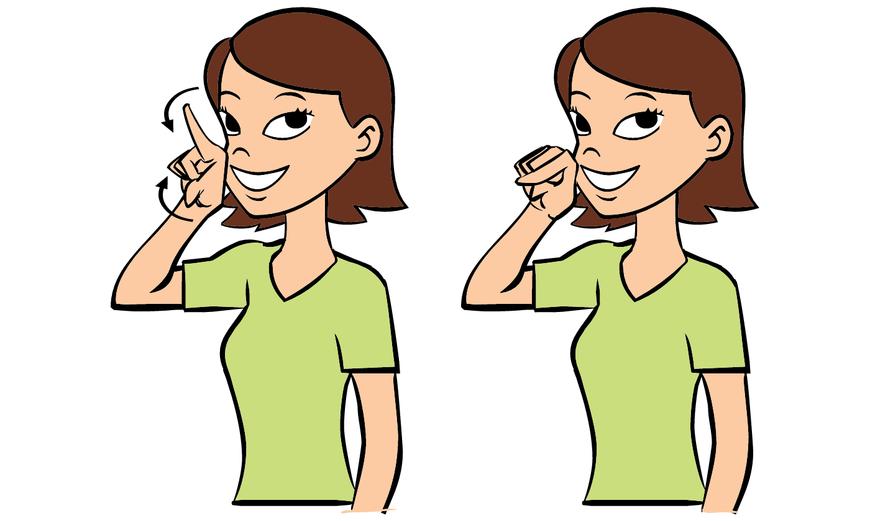

Bug-bicho


LEARNING STANDARDS Spotlight:
Science
Component 4: Life Science
Standard 4.a: Children begin to learn about the characteristics, needs, and life cycles of living things and how they get their needs met within a particular environment.

Important Dates / Events
3/2: Dr. Seuss’s Birthday
3/2 – 3/6: Dr. Seuss Spirit Week
3/16: Bring in Lepruchaun Traps
3/17: St. Patricks Day Wear Green To School

*Project Chick Begins TBD
Family Participation
Lepruchaun Traps for Lucky The Lepruchaun

Lepruchauns are very clever, especially Lucky. We need to outsmart him. Its your families job to build a leprechaun trap so we can catch him. Make a trap at home with your family, you can bring it in if you would like but it is not mandatory. The more traps the better! We will catch him one way or another!
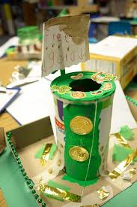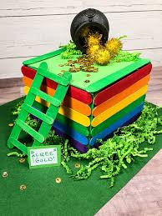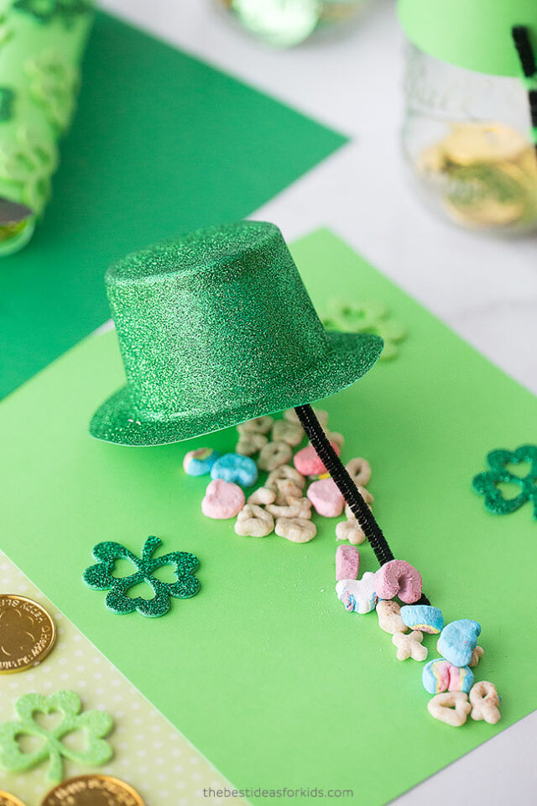
Author of the Month
Dr. Seuss


Books Written By Dr. Seuss
The Cat in the Hat
Green Eggs and Ham
Fox in Socks
Oh the Places You’ll Go
One Fish, Two Fish, Red Fish, Blue Fish

Weekly Themes
3/30-4/3: Easter (Eggs, Bunnies)
4/6-4/10: Dinosaurs (Fossils)
4/13-4/17: More Dinosaurs (Fossils)
4/20-4/24: Reduce, Reuse and Recycle
4/27-5/1: On the Farm

April
Earth Exploration


Monthly Concepts

Letters: K, W, Z
Numbers: 15, 16
Color: Blue
Shape: Oval
Country: France
Culinary: Earth Day Dirt Cups
Art Medium: Recycled items 3d art
Sight Words: all, the

Spanish and Sign Language:
Earth – Tierra
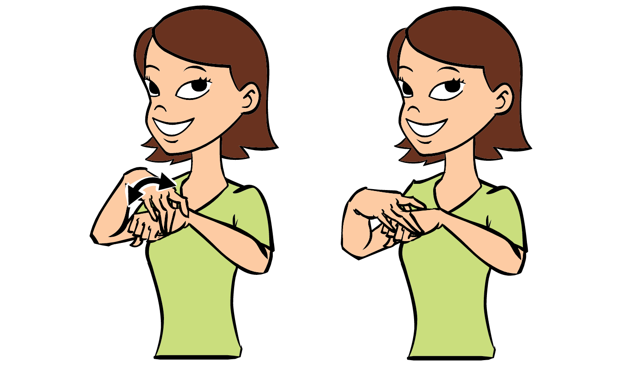
Rain - lluvia

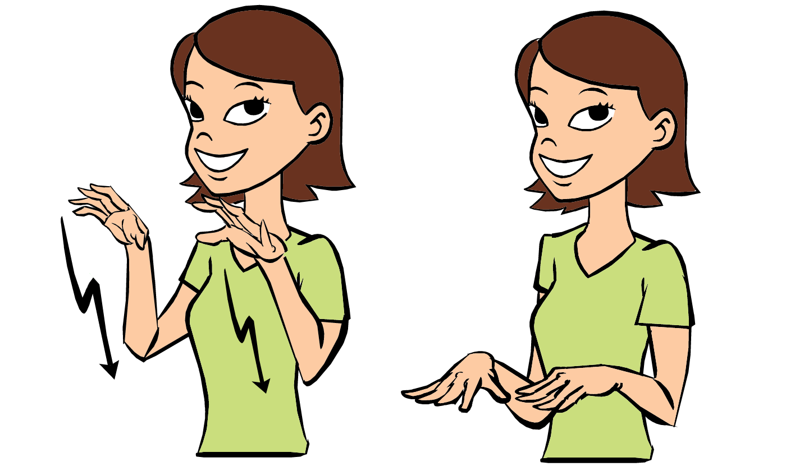
LEARNING STANDARDS Spotlight:
Science
Component 3: Earth and Space Science
Standard 3.a: Children gain increasing knowledge of the features of earth and space, the components of weather, and how all living things depend on natural resources to survive.

Important Dates / Events
4/3: PD/Deep Clean Day ELA closes at 12 PM
4/5: Easter Sunday
4/6-4/10: Week of the Young Child
4/17: Wear Blue to School
4/20: Patriots Day ELA closed

*Spring Pictures TBD
*Spring Fling TBD

Author of the Month
Alice Schertle


Books Writtenn by Alice Schertle
Little Blue Truck
Little Blue Truck Leads the Way
Little Blue Truck Springtime
Little Blue Truck Feeling Happy

Family Participation
Umbrella Mobile
Choose between a rain drop, cloud, or butterfly template in the front hallway. Decorate however you would like, cut it out anr return it to school. When it is returned it will be haded to our school wide umbrella mobile!

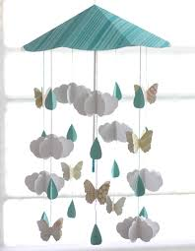
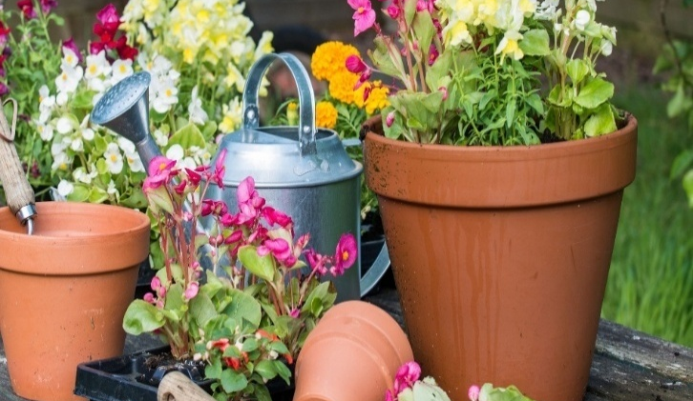
Weekly Themes
5/4 – 5/8: Gardening / Flowers
5/11 – 5/15: Construction / Transportation
5/18-5/22: Very Hungry Caterpillar Week
5/25 – 5/29: Zoo / Safari

May
Miscellaneous May

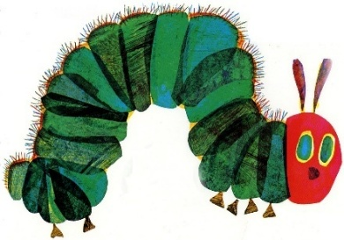
Monthly Concepts

Letters: E, U, V
Numbers: 17, 18
Color: Purple
Shape: Pentagon
Country: Mexico
Culinary: Cinco De Mayo Tacos
Art Medium: Flower petals, stems, paint, paper
Sight Words: that, with

Spanish and Sign Language:
Flower- flor
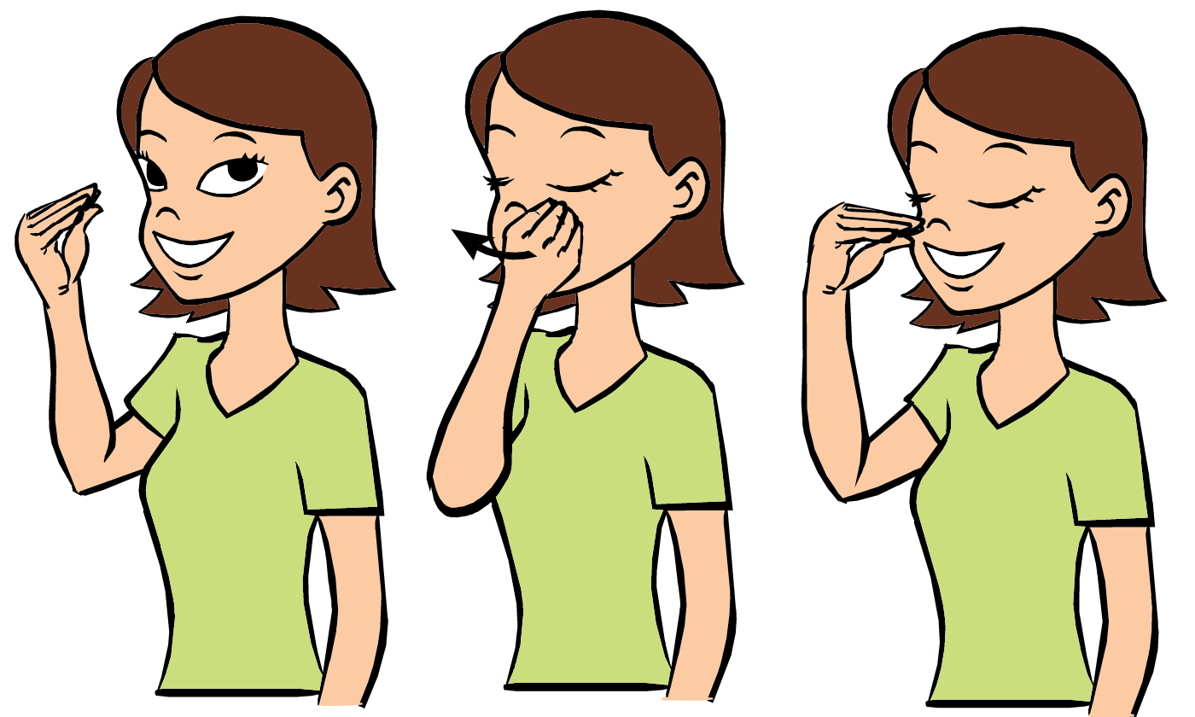

Car - coche
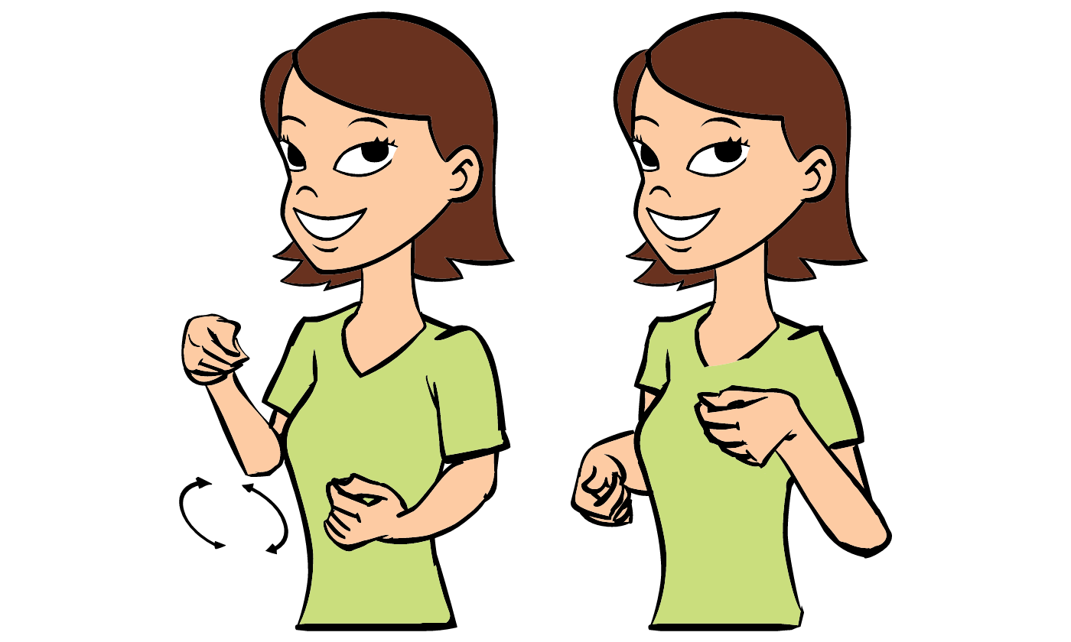
LEARNING STANDARDS Spotlight:
Cognitive
Component 1: Logic and Reasoning
Standard 1.a: Children apply strategies and draw upon past knowledge and experiences to meet goals and solve problems.

Important Dates / Events
5/4-5/8: Teacher Appreciation Week
5/5: Cinco De Mayo
5/8: Muffins for Moms
5/10: Mothers Day
5/15: Wear Purple to School
5/25: Memorial Day ELA Closed

*ELA Rock Garden TBD

Family Participation
Design your own flower
Take a flower pot template from the front hallway! Design your own flower using crayons, markers, paint and any materials you can find around your home. Don’t forget to name your flower. Once completed return to Miss. Andrea to be displayed in the hallway.
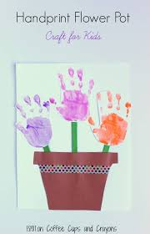
Author of the Month
Eric Carl


Books Written by Eric Carl
The Very Hungry Caterpillar
The Tiny Seed
The Grouchy Lady Bug
The Very Busy Spider
The Mixed up Chameleon


Weekly Themes
6/1-6/5: Space Exploarion
6/8-6/12: Medievil / Fairytales
6/15-6/19: Teachers Choice
6/22-6/26: Pirates and Tropical Islands
6/29-6/30: When I Grow Up

June
Imaginative Adventures


Monthly Concepts

Letters: Q,Y
Numbers: 19, 20
Color: Gray
Shape: Octogon
Country: Japan
Culinary: Moon Rice Cake
Art Medium: Playdough or clay
Sight Words: you, us

Spanish and Sign Language:
Summer- verano


Moon - luna

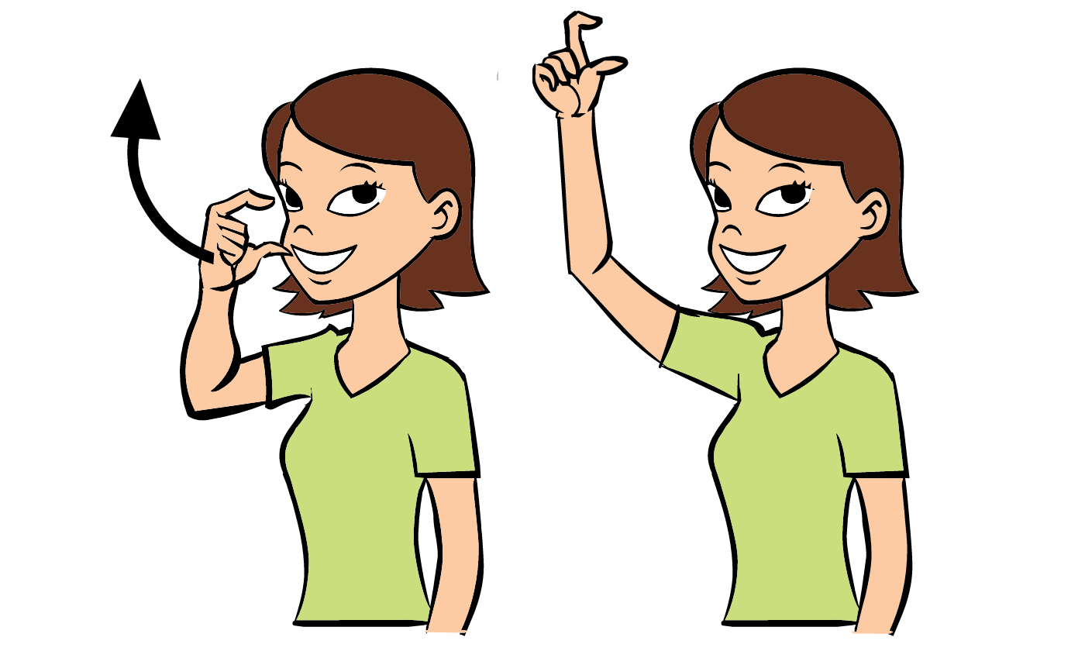

LEARNING STANDARDS Spotlight:
Creative Arts
Component 1: Experimentation and Participation in the Creative Arts
Standard 1.a: Children gain an appreciation for and participate in the creative arts related to music & movement, drama, and the visual arts.

Important Dates / Events
6/12: Wear gray to school
6/18: Donuts for Dad
6/19: Juneteenth ELA Closed

*Aquarium Program TBD
Author of the Month
Laura Numeroff


Books Written By Laura Numeroff
If You Give A Mouse A Cookie
If You Give A Moose A Muffin
If You Give A Pig a Pancake
If you Give a Dog a Donut

Family Participation
Imagination Art
Take a paint splatter template from the front hall. Encourage your child to use their imagination to turn the spatter of paint on the paper into something else! Return your aurtwork to school so it can be displayed!

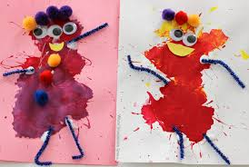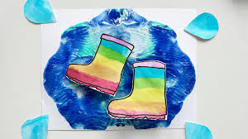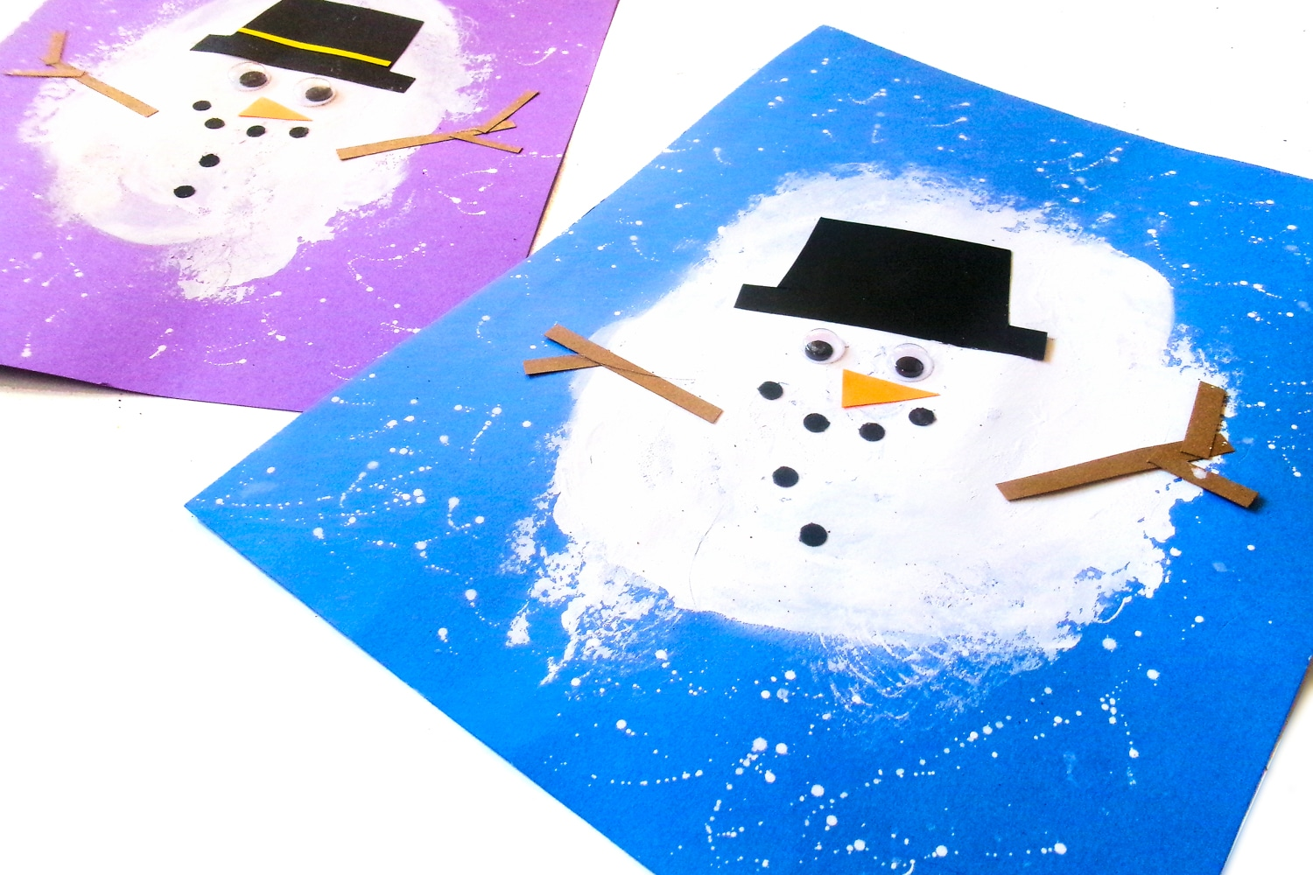

Weekly Themes
7/6-7/10: Party in the U.S.A
7/13-7/17: Summer Treats
7/20-7/24: Coral Reef Explorers
7/27-7/31: Summer Spirit Week / Bubbles

July
America the Beautiful


Monthly Concepts

Letters: Review A-M
Numbers: Review 1-10
Color: Red, White and Blue
Shape: Review
Country: U.S.A
Culinary: Jello Aquariums
Art Medium: Firework art, string, pipe cleaners, forks, red white and blue paint
Sight Words: from, some

Spanish and Sign Language:
Fun- divertido
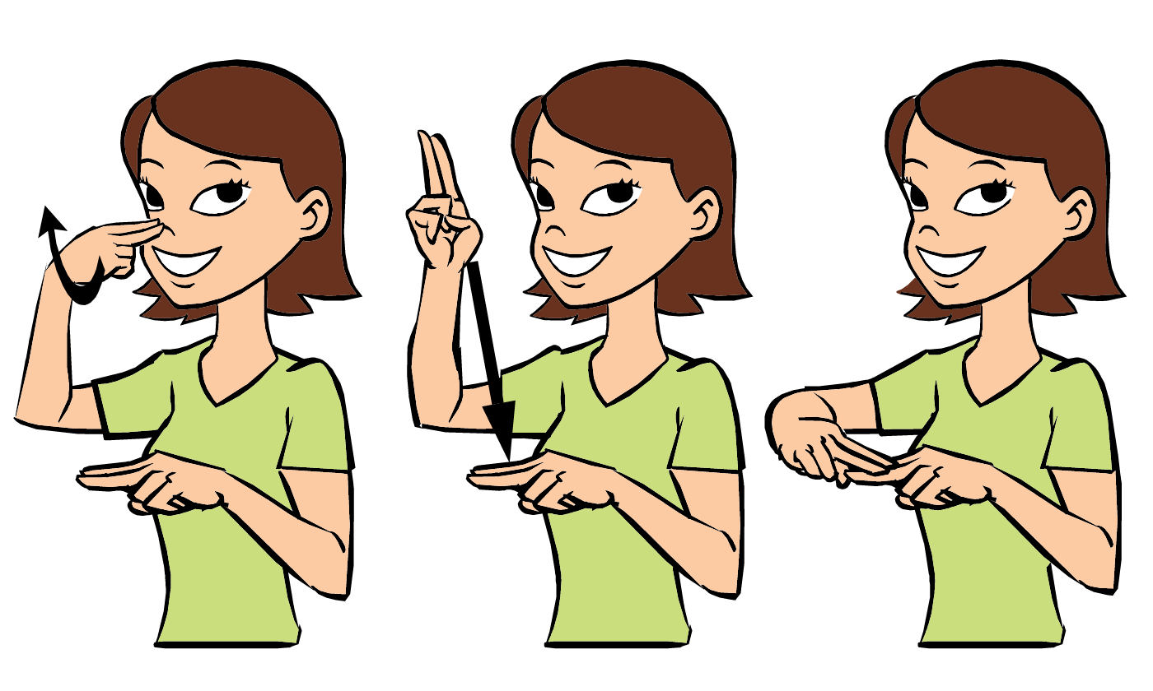

Fish- Pez


LEARNING STANDARDS Spotlight:
Physical Health and Motor Development
Component 2: Gross Motor Development
Standard 2.a: Children develop large muscle control, strength, and coordination.

Family Participation
Art exhbit
Create your own piece of art to display at our art exhibit at the end of July. This piece of art can be anything youd like. A canvas painting, a paper craft, a portiat, a 3d Craft. Get Creative!

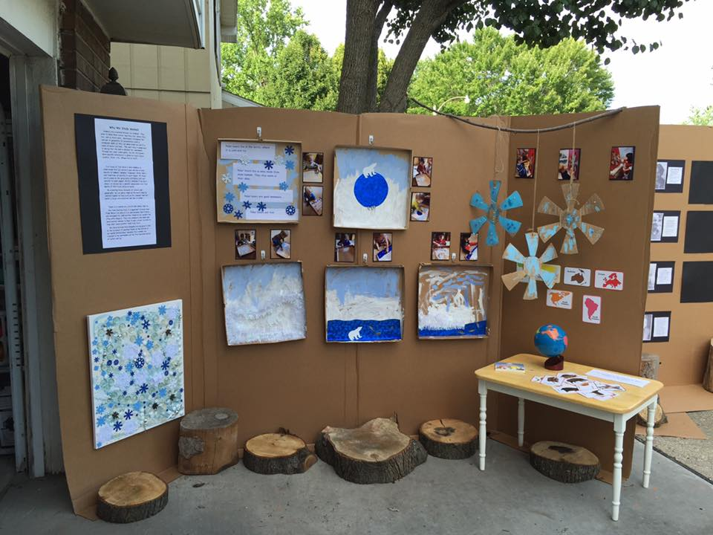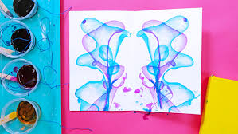
Important Dates / Events
7/1-7/3: July Break ELA Closed
7/10: Wear red, white and blue to School
7/27-7/31: Summer Spirit Week

*Magic Show TBD
Summer Spirit Week
7/27 – 7/31

Monday 7/27: Lemonade Day
Kpreps Lemonade Stand. K-Prep will deliver lemonade to each classroom. Teachers stop at the stand for a cup!

Tuesday 7/28: Sports Day
Dress up in your favore sports attire

Wednesday 7/29: Superhero & Princess Day
Dress like your favorite superhero or princess

Thursday 7/30: Beach Day
Dress up in swimwear (cover ups as well), bring beach hats and sunglasses, goggles.

Friday 7/31: Ice Cream Day
An ice cream / popsicle sweet treat to enjoy outdoors

Weekly Themes

8/3-8/7: Beach Vibes (Seashells, sandcastles)
8/10-8/14: Camping/Close to Nature
8/17-8/21: Picnics and Ants
8/24-8/28: Carnival / Circus

August
Fun in the Sun


Family Participation
Closer to Nature walk

Take a walk as a family, maybe a walk on the beach, a walk in the park, on the closest bike path, or even in your neighborhood. During the walk encouarage your child to be observant, talk about what you see and hear. When you get home have your child draw a picture of what they seen on their walk or make a collage of what they found. They can bring their picture to school to share with their friends.
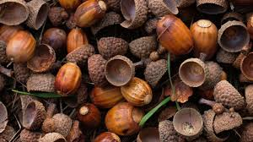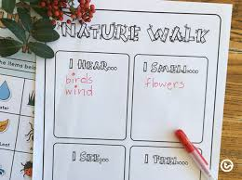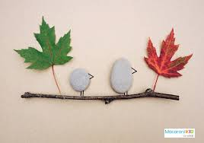
Monthly Concepts

Letters: Review N-Z
Numbers: Review 11-20
Color: Rainbow
Shape: Review
Country: Canada
Culinary: Homemade Lemonade
Art Medium: Sensory shaving cream with rainbow sprinkles
Sight Words: clock, table

Spanish and Sign Language:
Sun- sol


Beach- playa

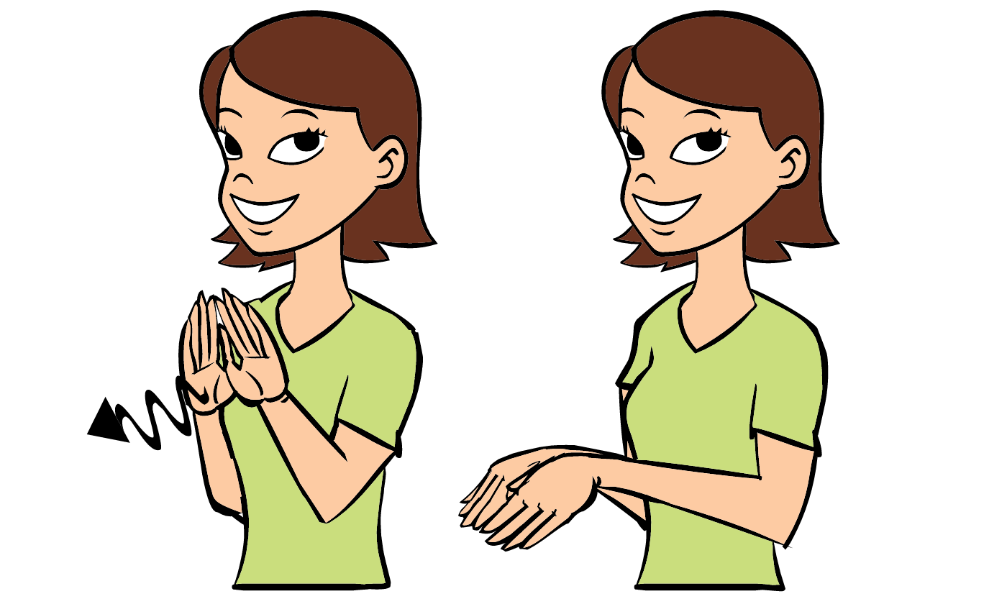

LEARNING STANDARDS Spotlight:
Physical Health and Motor Development
Component 3: Fine Motor Development
Standard 3.b: Children develop writing and drawing skills.

Important Dates / Events
8/14: Rainbow Day ; Wear as many colors as you want!

*End of the Year Party
*Magic Show TBD

